ED Use Predictions

PCL WCC Population

Full Population:

Call:

glm(formula = High.ED.Utilization.Indicator ~ Age.Group + Problem.Count +

CCC.Count + CCC.CVD + CCC.GI + CCC.Hem.Imm + CCC.Renal +

Public.or.Private.Metric + ED.Triage.Acuity + Acute.URI.DX +

Asthma.DX + Cough.DX + Long.Term.Drug.Therapy.DX + Prior.ED.Visit.Count +

Major.Region + Race.and.Ethnicity.Group + ED.Shift, family = binomial(logit),

data = EDPredictors.2016.df)

Deviance Residuals:

Min 1Q Median 3Q Max

-2.5130 -0.4680 -0.2855 -0.1575 2.9094

Coefficients:

Estimate Std. Error z value Pr(>|z|)

(Intercept) -2.75327 0.75853 -3.630 0.000284 \*\*\*

Age.Group1 thru 3 years -0.82990 0.18272 -4.542 5.57e-06 \*\*\*

Age.Group13 years or more -1.51411 0.20732 -7.303 2.81e-13 \*\*\*

Age.Group3 thru 11 months -0.20575 0.19728 -1.043 0.296977

Age.Group4 thru 12 years -1.69864 0.19010 -8.935 < 2e-16 \*\*\*

Problem.Count 0.11344 0.01053 10.771 < 2e-16 \*\*\*

CCC.Count -0.20178 0.05776 -3.493 0.000477 \*\*\*

CCC.CVD 0.28183 0.13698 2.057 0.039641 \*

CCC.GI 0.57871 0.18741 3.088 0.002016 \*\*

CCC.Hem.Imm 0.43125 0.14937 2.887 0.003889 \*\*

CCC.Renal 0.41001 0.17024 2.408 0.016020 \*

Public.or.Private.MetricPublic 0.38004 0.16524 2.300 0.021448 \*

Public.or.Private.MetricUnavailable 0.38499 0.33384 1.153 0.248827

ED.Triage.Acuity2 1.06933 0.62134 1.721 0.085250 .

ED.Triage.Acuity3 0.94871 0.62166 1.526 0.126987

ED.Triage.Acuity4 0.75103 0.62791 1.196 0.231672

ED.Triage.Acuity5 1.00477 0.64263 1.564 0.117929

ED.Triage.AcuityUnknown 0.31257 0.87929 0.355 0.722230

Acute.URI.DX 0.18405 0.11197 1.644 0.100224

Asthma.DX 0.43507 0.10118 4.300 1.71e-05 \*\*\*

Cough.DX -0.55764 0.15005 -3.716 0.000202 \*\*\*

Long.Term.Drug.Therapy.DX 0.30844 0.08768 3.518 0.000435 \*\*\*

Prior.ED.Visit.Count 1.43626 0.04176 34.390 < 2e-16 \*\*\*

Major.RegionLocal -0.89051 0.34212 -2.603 0.009242 \*\*

Major.RegionNational -1.36313 0.78316 -1.741 0.081763 .

Major.RegionRegional -1.22522 0.50052 -2.448 0.014370 \*

Major.RegionUnknown -0.22915 0.80468 -0.285 0.775819

Race.and.Ethnicity.GroupBlack or African American 0.07952 0.29499 0.270 0.787491

Race.and.Ethnicity.GroupHispanic or Latino 0.27338 0.29386 0.930 0.352209

Race.and.Ethnicity.GroupOther -0.23072 0.30511 -0.756 0.449541

Race.and.Ethnicity.GroupWhite 0.14816 0.33216 0.446 0.655558

ED.ShiftEvening -0.15510 0.08520 -1.820 0.068712 .

ED.ShiftOvernight -0.19335 0.12368 -1.563 0.117991

---

Signif. codes: 0 ‘\*\*\*’ 0.001 ‘\*\*’ 0.01 ‘\*’ 0.05 ‘.’ 0.1 ‘ ’ 1

(Dispersion parameter for binomial family taken to be 1)

Null deviance: 7953.2 on 7283 degrees of freedom

Residual deviance: 4448.4 on 7251 degrees of freedom

AIC: 4514.4

Number of Fisher Scoring iterations: 6

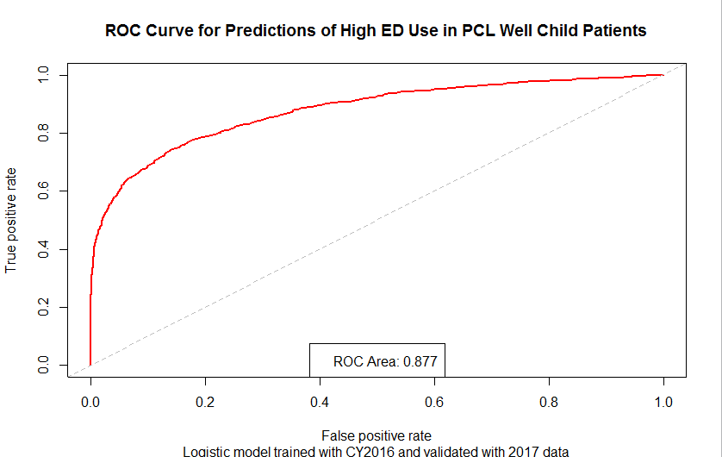

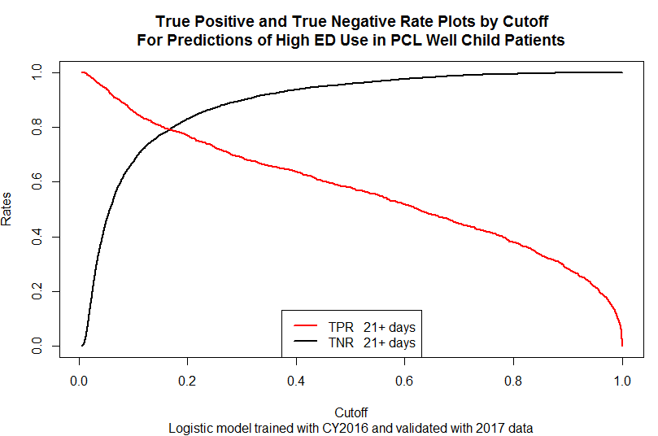

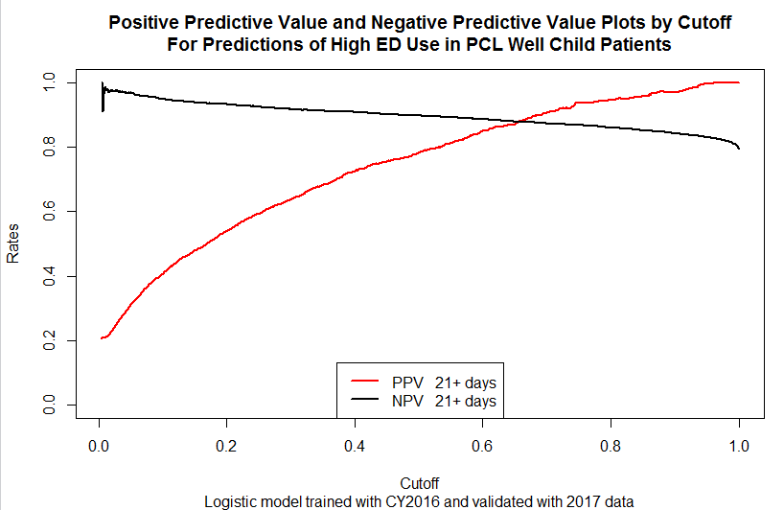

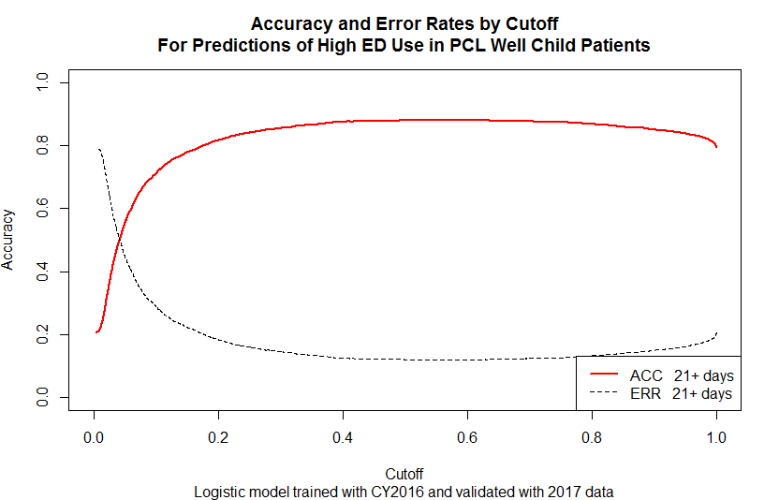

Low Acuity (4&5):

Call:

glm(formula = High.ED.Utilization.Indicator ~ Age.Group + Problem.Count +

CCC.Count + CCC.Congenital + CCC.CVD + CCC.GI + CCC.Hem.Imm +

CCC.Metabolic + CCC.Misc + CCC.Renal + Public.or.Private.Metric +

Med.Date.Time.Ind + Order.Date.Time.Ind + Abdominal.and.Pelvic.Pain.DX +

Acute.URI.DX + Cough.DX + Prior.ED.Visit.Count + ED.Shift,

family = binomial(logit), data = EDPredictorsLowAcuity.2016.df)

Deviance Residuals:

Min 1Q Median 3Q Max

-1.6490 -0.2665 -0.1627 -0.1018 3.1710

Coefficients:

Estimate Std. Error z value Pr(>|z|)

(Intercept) -19.52200 658.67025 -0.030 0.976355

Age.Group1 thru 3 years 13.10326 658.66983 0.020 0.984128

Age.Group13 years or more 12.82208 658.66994 0.019 0.984469

Age.Group3 thru 11 months 14.43039 658.66983 0.022 0.982521

Age.Group4 thru 12 years 12.61889 658.66984 0.019 0.984715

Problem.Count 0.11089 0.03202 3.464 0.000533 \*\*\*

CCC.Count -1.73786 0.44272 -3.925 8.66e-05 \*\*\*

CCC.Congenital 1.91791 0.69793 2.748 0.005996 \*\*

CCC.CVD 1.40605 0.61972 2.269 0.023277 \*

CCC.GI 2.82496 0.93146 3.033 0.002423 \*\*

CCC.Hem.Imm 2.60786 0.59013 4.419 9.91e-06 \*\*\*

CCC.Metabolic 1.75850 0.78425 2.242 0.024945 \*

CCC.Misc -17.42093 806.99349 -0.022 0.982777

CCC.Renal 2.05196 0.66054 3.106 0.001893 \*\*

Public.or.Private.MetricPublic 1.77115 0.74369 2.382 0.017239 \*

Public.or.Private.MetricUnavailable 0.88937 1.06675 0.834 0.404441

Med.Date.Time.Ind 0.38158 0.21284 1.793 0.073008 .

Order.Date.Time.Ind 0.41317 0.22193 1.862 0.062639 .

Abdominal.and.Pelvic.Pain.DX -1.05869 0.78109 -1.355 0.175290

Acute.URI.DX 0.66539 0.21154 3.145 0.001658 \*\*

Cough.DX -1.23505 0.42567 -2.901 0.003714 \*\*

Prior.ED.Visit.Count 1.90546 0.10442 18.249 < 2e-16 \*\*\*

ED.ShiftEvening -0.17338 0.18860 -0.919 0.357934

ED.ShiftOvernight -1.04774 0.33044 -3.171 0.001521 \*\*

---

Signif. codes: 0 ‘\*\*\*’ 0.001 ‘\*\*’ 0.01 ‘\*’ 0.05 ‘.’ 0.1 ‘ ’ 1

(Dispersion parameter for binomial family taken to be 1)

Null deviance: 1703.76 on 3129 degrees of freedom

Residual deviance: 955.11 on 3106 degrees of freedom

AIC: 1003.1

Number of Fisher Scoring iterations: 16

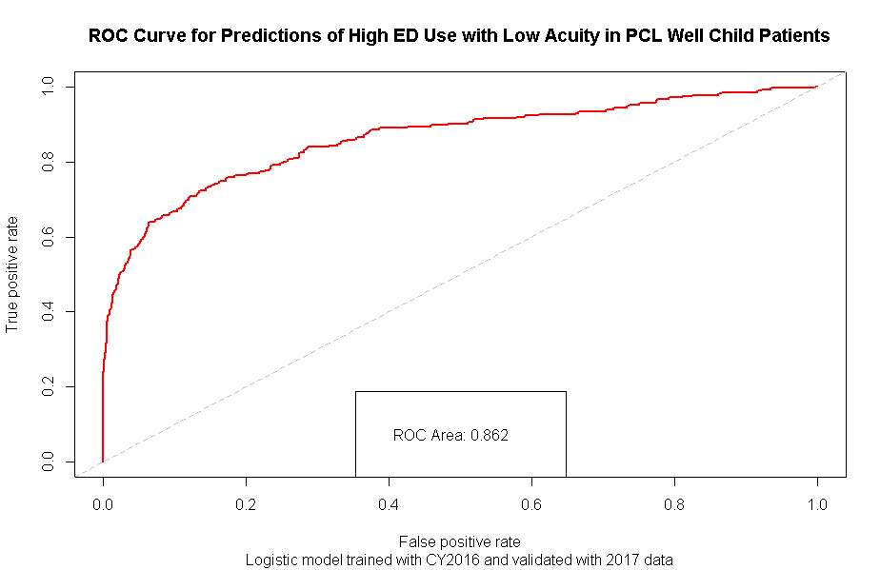

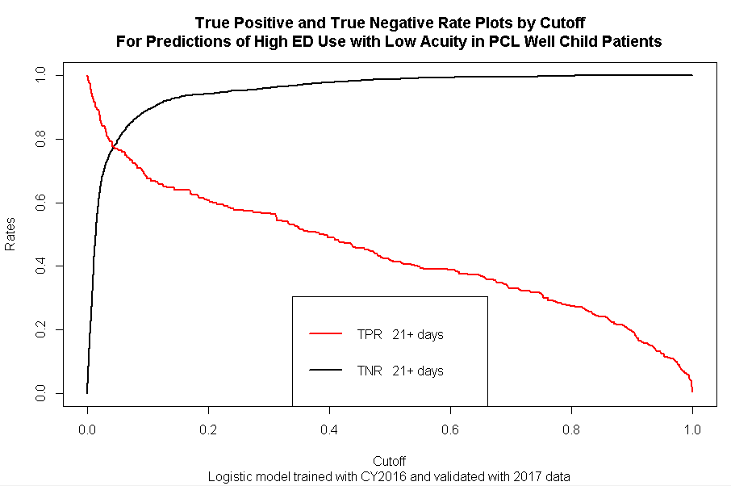

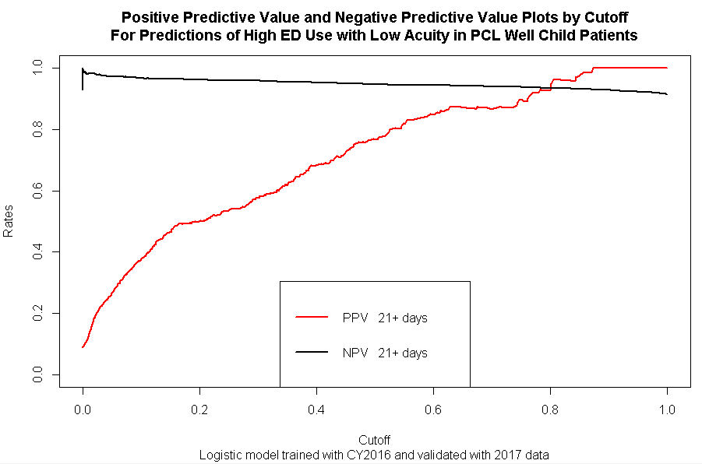

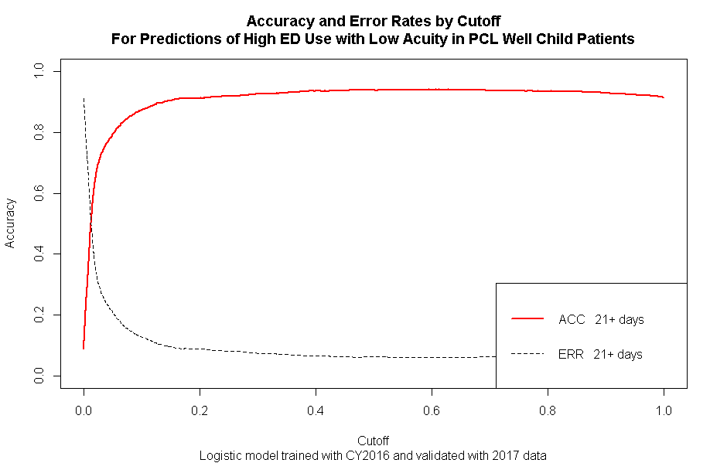

Low Activity (Med, Orders and Lab indicators all 0):

Call:

glm(formula = High.ED.Utilization.Indicator ~ Age.Group + Problem.Count +

CCC.Metabolic + CCC.Neuromuscular + Holiday.Indicator + ED.Checkin.Hour.Metric +

ED.Triage.Acuity + Acute.URI.DX + Asthma.DX + Nausea.and.Vomiting.DX +

Prior.ED.Visit.Count, family = binomial(logit), data = EDPredictorsLowuse.2016.df)

Deviance Residuals:

Min 1Q Median 3Q Max

-2.1385 -0.4394 -0.2505 -0.1274 3.0186

Coefficients:

Estimate Std. Error z value Pr(>|z|)

(Intercept) -13.17052 604.10015 -0.022 0.982606

Age.Group1 thru 3 years -1.32165 0.32195 -4.105 4.04e-05 \*\*\*

Age.Group13 years or more -1.75882 0.47042 -3.739 0.000185 \*\*\*

Age.Group3 thru 11 months -0.57510 0.33438 -1.720 0.085448 .

Age.Group4 thru 12 years -2.26859 0.37231 -6.093 1.11e-09 \*\*\*

Problem.Count 0.17388 0.02499 6.959 3.44e-12 \*\*\*

CCC.Metabolic -0.90107 0.56357 -1.599 0.109850

CCC.Neuromuscular -1.03777 0.41484 -2.502 0.012362 \*

Holiday.Indicator 0.82782 0.49272 1.680 0.092937 .

ED.Checkin.Hour.Metric 0.02397 0.01452 1.651 0.098668 .

ED.Triage.Acuity2 10.82374 604.10021 0.018 0.985705

ED.Triage.Acuity3 10.64465 604.10009 0.018 0.985941

ED.Triage.Acuity4 9.96296 604.10010 0.016 0.986842

ED.Triage.Acuity5 10.50418 604.10012 0.017 0.986127

ED.Triage.AcuityUnknown 10.11327 604.10104 0.017 0.986643

Acute.URI.DX 0.46821 0.23246 2.014 0.043997 \*

Asthma.DX 0.45837 0.29409 1.559 0.119095

Nausea.and.Vomiting.DX -0.74040 0.47720 -1.552 0.120767

Prior.ED.Visit.Count 1.73692 0.11033 15.743 < 2e-16 \*\*\*

---

Signif. codes: 0 ‘\*\*\*’ 0.001 ‘\*\*’ 0.01 ‘\*’ 0.05 ‘.’ 0.1 ‘ ’ 1

(Dispersion parameter for binomial family taken to be 1)

Null deviance: 1529.97 on 1485 degrees of freedom

Residual deviance: 819.42 on 1467 degrees of freedom

AIC: 857.42

Number of Fisher Scoring iterations: 13

